Fall 2021
Student Showcase for Research and Creative Inquiry
Presentation Guidelines

https://symposium.foragerone.com/longwood-university-fall-2021-student-showcase

The Fall 2021 Student Showcase for Research and Creative Inquiry is open to all students and all majors who are engaging in research and creative inquiry. Students doing independent study projects, research projects, and class projects are invited to participate. Posters, oral presentations, performances, visual displays, and other presentations of creative work will be showcased.

The Fall 2021 Student Showcase will be a hybrid event and students will be able to select from two presentation options:

1) Oral presentations and performances will occur live and in-person during the Fall Student Showcase on November 17. A Zoom link will also be provided for each session to allow virtual attendance at these live, in-person events.

**** For students giving live, in-person presentations, you do not need to submit a pre-recorded presentation to the ForagerOne Symposium platform. Please bring your presentation file to your live, in-person session on November 17, 2021.

2) Poster presentations, visual art displays, and pre-recorded oral presentations will be virtual and will be posted on the ForagerOne Symposium platform. Students will pre-record their presentations and will post these along with their posters/images of their artwork. In addition, during the Fall Student Showcase on November 17, each student will have a dedicated video chat room where people can discuss the student’s project with the student in real-time. Viewers will also be able to leave written comments and questions for the presenters within the ForagerOne Symposium platform.

**** Students who have pre-recorded presentations will need to read through the instructions below to learn more about how to prepare their pre-recorded presentations and how to submit them to the virtual ForagerOne Symposium platform that will be used for the Fall 2021 Student Showcase.

The deadline for submitting pre-recorded presentation files is November 15, 2021 at 11:59pm.
https://symposium.foragerone.com/longwood-university-fall-2021-student-showcase/submission ​

We hope that this will provide flexibility to prerecord presentations or to give live, in-person presentations. Please reach out to Amorette Barber (barberar@longwood.edu) if you would like to discuss which presentation format would work best for you.

PRE-RECORDED POSTER PRESENTATION GUIDELINES

The ideal poster is designed to tell the story of your research project--what question(s) did you ask, how did you strive to answer your question(s), and what did you conclude from your studies? Where are you now? Is this the end of your work, or a step in a longer journey? What have you learned through your research? What is the key idea you would like your audience to remember about your project?

Consider your audience members, who are not experts in your field, in order to invite conversation and attract attention.

POSTER PRESENTATION

You can use PowerPoint or Google Slides to make your poster. Getting started instructions are below.

Your Poster Presentation will include the following:
- .pdf file upload of your poster
- a link to an online Youtube video (~5-minute presentation)

POSTER SPECIFICATIONS

- Dimensions: Final poster dimensions can be up to a maximum of 48″ wide x 36" tall landscape format or 36” wide x 48 “ tall vertical format (although the posters will not be printed, these dimensions impact the scale of your materials.)
- Poster Templates: Please visit these websites if you would like to view and use a free poster template:
  - Longwood University Poster Templates
  - https://www.posterpresentations.com/free-poster-templates.html
  - https://www.genigraphics.com/templates

- Saving instructions: Your poster will be uploaded to the ForagerOne site. Instructions to follow.
  - Name your poster file with the following format:
[Last name First name] Class name (or Research if it is not for a class) Poster
    - Example: Barber Amorette BIOL 404 Poster.pdf
    - Example: Barber Amorette Research Poster.pdf

GETTING STARTED with PowerPoint

- In PowerPoint, begin by creating a 1-slide PowerPoint presentation - choose a blank slide. (The entire poster must be contained in only one slide.)
- Adjust the slide size to make the poster dimensions a maximum of 36″ x 48″ or 48” x 36” or a smaller size if desired.
- Save your poster as a .pptx file while you are working on it. (When you are all finished and ready to submit your poster, save a copy as .pdf)
- The poster file size may not exceed 10MB
- If needed, use an online tool such as Smallpdf to compress the file.

GETTING STARTED with Google Slides

- Go to slides.google.com in your browser
- Click the big “+” symbol to start a new slideshow
- In “File / Page Setup” choose “Custom” and set the size of your slide to 48” by 36” or 36” by 48” or to a smaller size if desired.
- In “Slide / Apply Layout” choose “Blank”
- When you are all finished and ready to submit your poster, choose “File / Download” and choose “PDF Document”
- Make sure your PDF does not exceed 10MB before submitting it.

POSTER PRESENTATION RECORDING GUIDELINES

Present as if you were at an in-person poster session. Aim to keep your presentation ~5 minutes.

The video should be a narration of your findings presented on the poster including:
- Your project goals
- Your main research activities
- What you learned

VIDEO
- Recording tools:
  - Zoom — Zoom is the preferred option for recording videos of your presentations. It is HIGHLY encouraged that students use Zoom to record your presentations. Zoom is also the best tool for group presentations. Your Longwood account allows you to record your narration of a slide presentation.
  - Panopto- Students are “viewers” in Panopto by default. Only students who have had a faculty member enable a Panopto Recordings [assignment] folder for a current or past course will have the ability to record.
  - iMovie
  - A phone or laptop
- Upload the file to YouTube.
- Privacy settings - select “unlisted” to make sure your video does not appear in search results or on your channel.
- If you need assistance with recording your presentation or with uploading your file to YouTube, please see the list of Help Guides created by the DEC at the end of this document and posted on the Student Showcase website: http://www.longwood.edu/studentresearch/student-showcase-for-research-and-creative-inquiry/

Pre-RECORDED ORAL PRESENTATION GUIDELINES

The ideal presentation is designed to tell the story of your research project--what question(s) did you ask, how did you strive to answer your question(s), and what did you conclude from your studies? Where are you now? Is this the end of your work, or a step in a longer journey? What have you learned through your research? What is the key idea you would like your audience to remember about your project?

Consider your audience members, who are not experts in your field, in order to invite conversation and attract attention.

ORAL PRESENTATION

You can use PowerPoint or Google Slides to make your presentation slides.

Your Oral Presentation will include the following:
1. A link to an online Youtube video of your presentation. Your presentation can be as long as you would like, there is not limit on the length of oral presentations.

ORAL PRESENTATION RECORDING GUIDELINES

Present as if you were at an in-person presentation session.

1. Record a video of yourself presenting your talk while showing your slides (if you are giving an oral presentation). We recommend recording your talk using Zoom and using screen share to show your slides while recording yourself talking about your slides or poster. Please be sure that: a) your face is well lit and b) your background is not distracting and is professional. Please double-check the quality of your recording before proceeding to Step 2.

2. Upload your video to YouTube, making sure to specify your video as Unlisted. This ensures that no one can see your video, except those that you share the link with. You will need a YouTube channel to upload your video to YouTube, if you don’t have one, you can create one for free at www.youtube.com

VIDEO
- Recording tools:
  - Zoom — Zoom is the preferred option for recording videos of your presentations. It is HIGHLY encouraged that students use Zoom to record your presentations. Zoom is also the best tool for group presentations. Your Longwood account allows you to record your narration of a slide presentation.
  - Panopto- Students are “viewers” in Panopto by default. Only students who have had a faculty member enable a Panopto Recordings [assignment] folder for a current or past course will have the ability to record.
  - iMovie
  - A phone or laptop

- Upload the file to YouTube.
- Privacy settings - select “unlisted” to make sure your video does not appear in search results or on your channel.
- If you need assistance with recording your presentation or with uploading your file to YouTube, please see the list of Help Guides created by the DEC at the end of this document.

UPLOADING TO FORAGERONE SYMPOSIUM
(You will receive more instructions AFTER you register for the Student Showcase.)

Please submit your presentation files here:
https://symposium.foragerone.com/longwood-university-fall-2021-student-showcase/submission ​

Students who selected the pre-recorded presentation option will need to upload their presentation files using this submission link. Students who are giving live, in-person presentations on November 17, 2021 do not need to submit their presentations on this submission site.

The deadline for submitting pre-recorded presentation files is November 15, 2021 at 11:59pm.

Through the submission form, students will fill out the information about themselves and any co-presenters, add their presentation title and abstract, and upload a PDF (which must be under 10 MB). Students will also submit a supplementary video through uploading their video to YouTube and sharing the link on the submission form. We recommend marking the video as unlisted to ensure the video does not appear on any public search, including YouTube or Google.
- How to upload videos to YouTube: https://support.google.com/youtube/answer/57407?co=GENIE.Platform%3DDesktop&hl=en

- How to make a video unlisted on YouTube: https://support.google.com/youtube/answer/157177?co=GENIE.Platform%3DDesktop&hl=en
- Uploading videos longer than 15 minutes to YouTube: https://support.google.com/youtube/answer/71673?co=GENIE.Platform%3DDesktop&hl=en

RESPONDING TO COMMENTS in FORAGERONE SYMPOSIUM
At any time during the conference (and for one year afterward) the prerecorded poster and oral presentations can be viewed. Viewers can leave written comments (compliments, thoughts, encouragements, and suggestions) for the presenters. Please be courteous in how you offer your critiques. The presenter will receive an email when a comment is posted and the presenter will have the opportunity to respond to the comments.
Expectations for presenters:
▪ Log into the Symposium website at least 3-4 times between November 17- November 24. You also will need to be logged into the Symposium website during your assigned poster session discussion time on November 17.
▪ Answer the questions and comments on your own presentation before the end of the day on November 17.
▪ Comment and engage with the presentations of your fellow presenters. An important part of presenting your project at a conference is learning about other projects in and outside of your discipline. Please explore the Symposium site and ask questions/leave comments for other presenters.
Guidelines for commenting:
▪ Questions, comments, and responses should be collegial and respectful of all presenters and visitors.
▪ Carefully read, view, and listen to posted work before posing thoughtful questions, civil comments, and/or constructive feedback.

ADDITIONAL RESOURCES

- Instructions to create your first YouTube video

Help Guides (From the Digital Education Collaborative (DEC))

Finding yourself in need of recording your presentation for the Student Showcase? The DEC officially supports a range of video recording options for students to utilize.

Either of the following options would serve as excellent recording tools for the showcase.

Click here to access the DEC Help Guide.

Getting Started: What should I use to Record?

- Panopto Capture
  - What is it?

    - Official lecture capture solution for Longwood University. Mostly used by faculty, but available to students.Record multiple sources (webcam, screen audio) simultaneously, edit videos after recording, and add more content after recording as needed. Highest possible audio/video quality of all supported options.
  - Requirements for use?
    - Mac/PC/mobile device with webcam and microphone. PC or Mac needed for editing videos. Login with Lancernet here to get started.
  - Why Panopto?
    - Panopto is an excellent tool if you wish to be able to quickly and easily make edits to a video after recording. It allows multiple inputs. The final product can be downloaded or shared as a link.
    - DEC recommends using Panopto only if you have used it previously for class.

- Zoom
  - What is it?

    - Official video conferencing solution for Longwood University. Record in-meeting interactions, share your screen, present with multiple people.
  - Requirements for use?
    - Mac/PC/mobile device with Zoom desktop client/app installed. Login with Lancernet here to get started.
  - Why Zoom?
    - Zoom is an excellent tool if you are recording a presentation with more than one person. It is straightforward and many students are already familiar with its set-up. This is an excellent tool if you do not plan on needing to make edits within the video after recording.

Now that you’ve selected a program in which to record, choose a Help Guide from the list below to learn more about how to record. Click on any of the below headings to get started!

- Recording a presentation using Zoom
Launching a Meeting
Screen Sharing
Recording Your Meeting

- Recording a presentation using Panopto
Using Panopto Capture (in-browser)

- Uploading existing media into Panopto
*Use this if you recorded in another program, but need to edit it in Panopto*

- Adding clips to a video in Panopto

- Making cuts to a video using Panopto

- Exporting your finished video to .mp4 “podcast”

- Creating an Unlisted Youtube Video
Video Version

Recording a presentation using Zoom

Launching a Meeting
- To launch a Zoom meeting with all available features, open the desktop app. If you have not already installed this on your computer, go to https://zoom.us/download.
- Sign into Zoom using your LancerNet credentials. To do this, select the option to sign in using SSO (single sign-on).
- Important Note: you may need to type in the Domain for Longwood’s Zoom account. If prompted, type in Longwood-edu in the domain field.
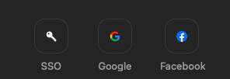
- Then, you will need to type in your Lancernet ID and password
- After logging in, go to the “Home” tab on the top menu.
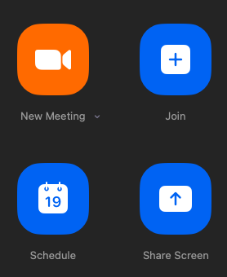
- There are a few different ways you may choose to start or join a meeting.
  - “New Meeting” instantly launches an unscheduled meeting.
  - “Schedule” allows you to plan a meeting and launch it at a future time. This allows a link to be distributed in advance. For guidance on how to schedule a meeting, check out our help guide. For tips on how to launch a scheduled meeting, check out this help guide!
  - “Join” allows you to enter a meeting that someone else started. To join this way, you will need a code and password (if applicable) given by the host.

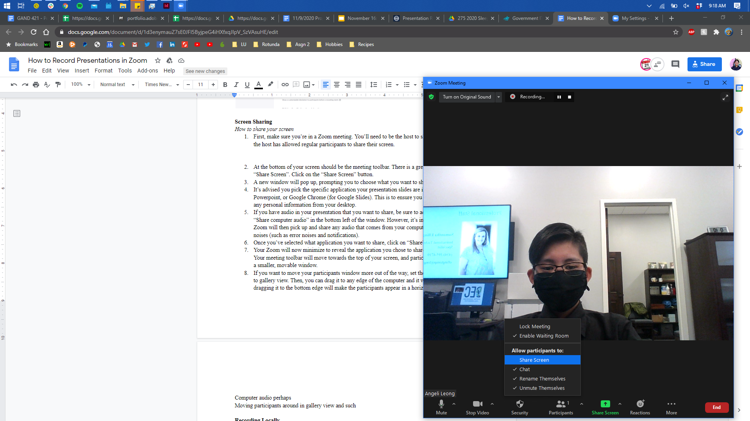

Screen Sharing
- First, make sure you’re in a Zoom meeting. You’ll need to be the host to share your screen, unless the host has allowed regular participants to share their screen. To allow participants to share their screen, click on “Security” along the toolbar and under “Allow participants to:”, enable “Share Screen”.
- At the bottom of your screen should be the meeting toolbar. There is a green button that says “Share Screen”. Click on the “Share Screen” button.

- A new window will pop up, prompting you to choose what you want to share.
- It’s advised you pick the specific application your presentation slides are in, whether it’s Keynote, Powerpoint, or Google Chrome (for Google Slides). This is to ensure you don’t accidentally show any personal information from your desktop.
- If you have audio in your presentation that you want to share, be sure to add a checkmark to the “Share computer audio” in the bottom left of the window. However, it’s important to note that Zoom will then pick up and share any audio that comes from your computer, including system noises (such as error noises and notifications).
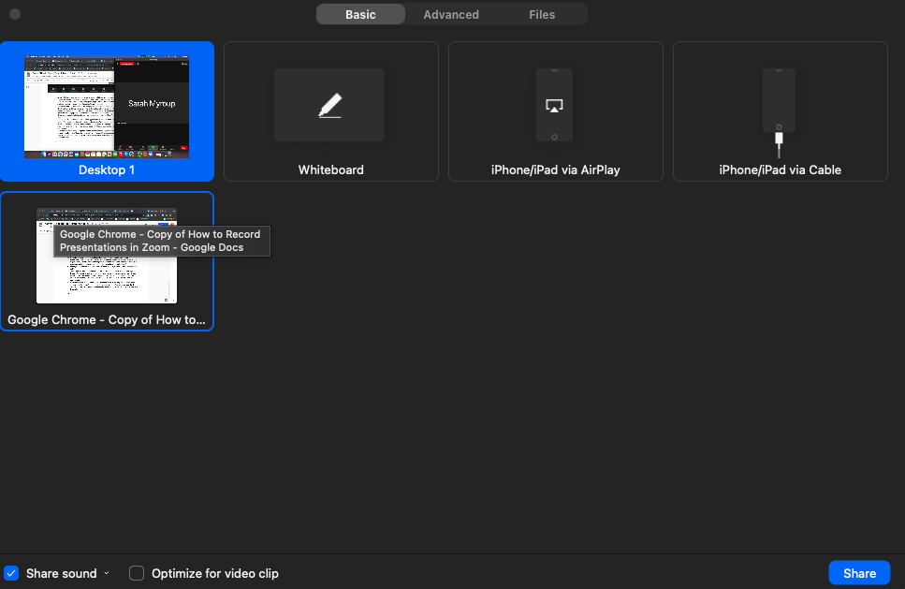
- Once you’ve selected what application you want to share, click on “Share” in the bottom right.

- Your Zoom will now minimize to reveal the application you chose to share with a green border.
- If you want to move your participants window more out of the way, set the participants window to gallery view. Then, you can drag it to any edge of the computer and it will align with it, such as dragging it to the bottom edge will make the participants appear in a horizontal row.

Recording Your Meeting
- Once in your meeting, locate the option to record on the bottom toolbar. By default, your meeting will begin recording and be stored on your local computer.
  - If you do not see the option, click on the three dots on the right hand side of the toolbar. This should reveal the option to record.
- In the upper left-hand corner of the screen, there will now be an icon indicating that the meeting is being recorded.

  - To pause the recording, click on the button with two horizontal lines. Resume it by clicking the triangle icon that will take the pause button’s place.
  - To end the recording, press the square button to stop.
- Once the meeting is finished, the recording will begin saving to your computer. Depending on the length of your recording, this may take some time. These recordings can be found in your computer’s files, likely in Documents and the Zoom folder.

Recording a presentation using Panopto

Using Panopto Capture (in-browser)
- Panopto Capture is a browser based recording software from Panopto, that does not require you to download software. It works directly in your web browser.
- Prerequisites:
  - Latest version of: Chrome, Edge (Chromium-based), or Firefox browsers on Windows 10, MacOS 10.15 or higher, or the latest ChromeOS. Capture is also in beta for Chrome and Firefox browsers on Android 9 or higher. Note: Please make sure anti-virus exceptions are made for audio (microphone), video (web camera), and screen in your preferred browser. Panopto plans to add support for Safari on desktop soon.
- In your “My Folder” at https://longwood.hosted.panopto.com/, click on the Create Button at the top of the video library, and select Panopto Capture.
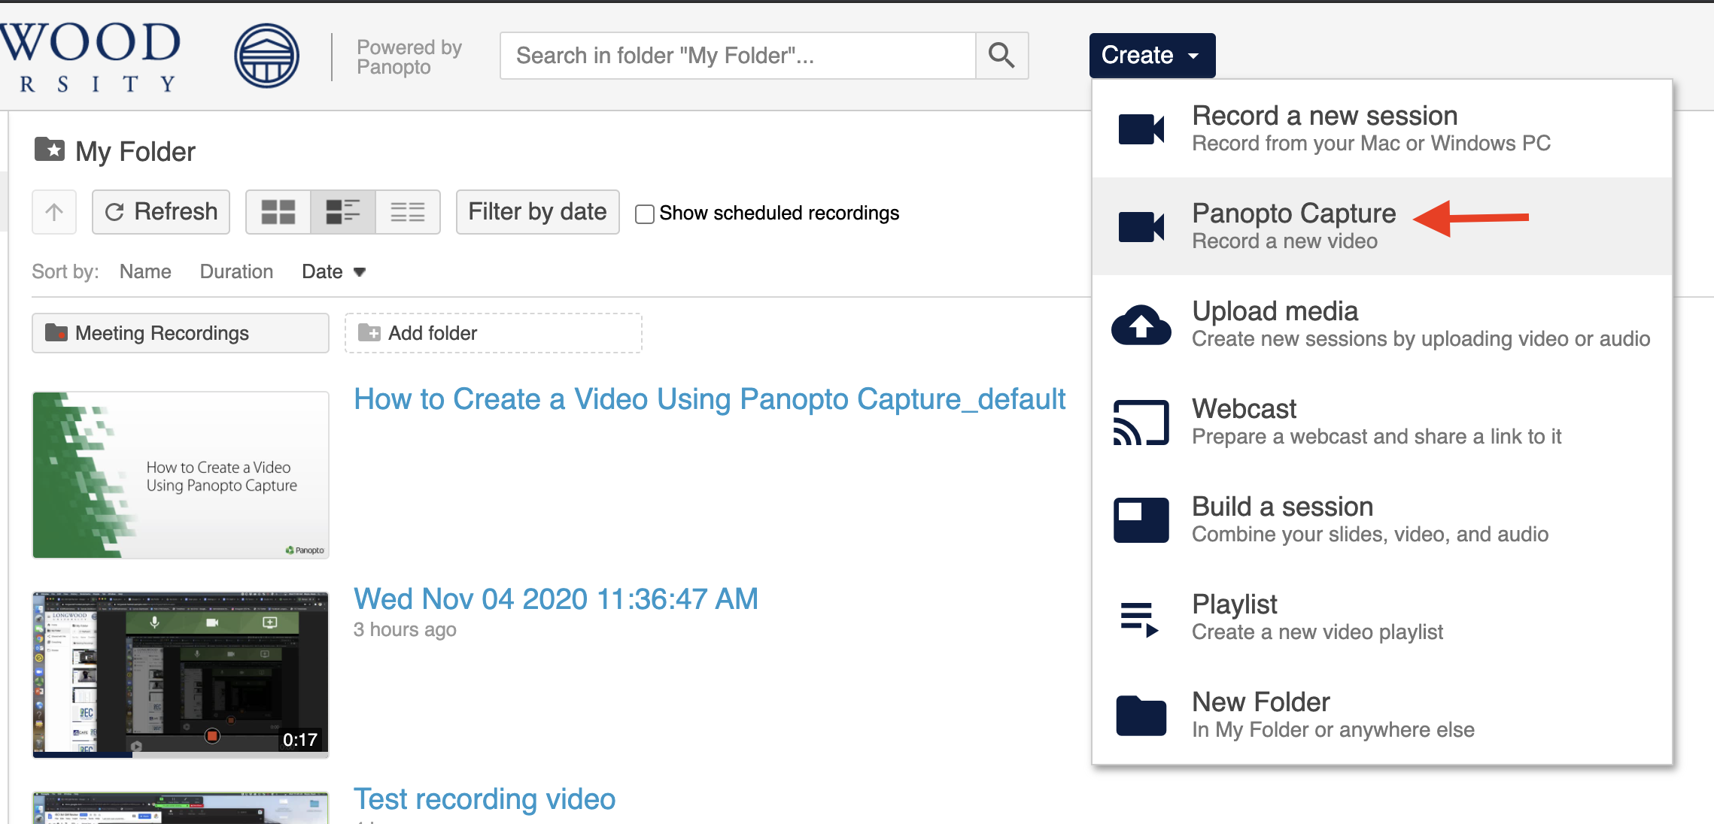

- When you open the browser-based recorder, you will see the screen below, with microphone, webcam, and screen recording options.
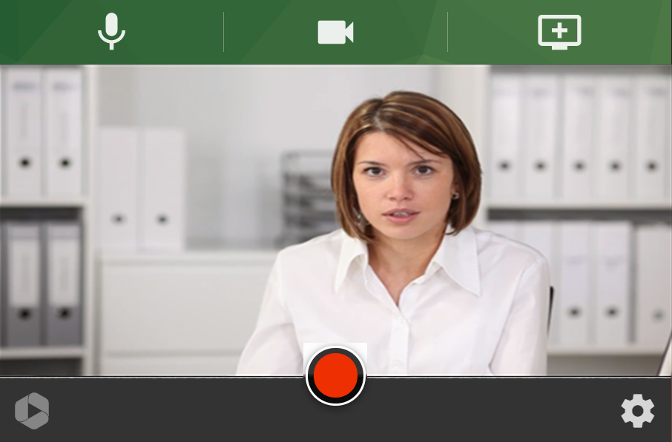
- The microphone icon allows you to select your intended microphone, the camera icon allows you to select the webcam you’d use to record yourself, and the “+ screens and apps” icon on the right allows you to choose an open powerpoint, google slides presentation, or other media that you’d like to be seen on your recording.
- Be sure to click on the intended resource to share before pressing record.
- When ready to record, pressing the record button starts a short countdown timer before beginning. Click the Stop button to end your recording.
  - Note: there is no “Pause” function in Panopto capture. When you press stop, your session is over.
  - Use Zoom if you need to “pause” your presentation periodically while recording
- After Stopping your recording, you will see a review screen as shown below.
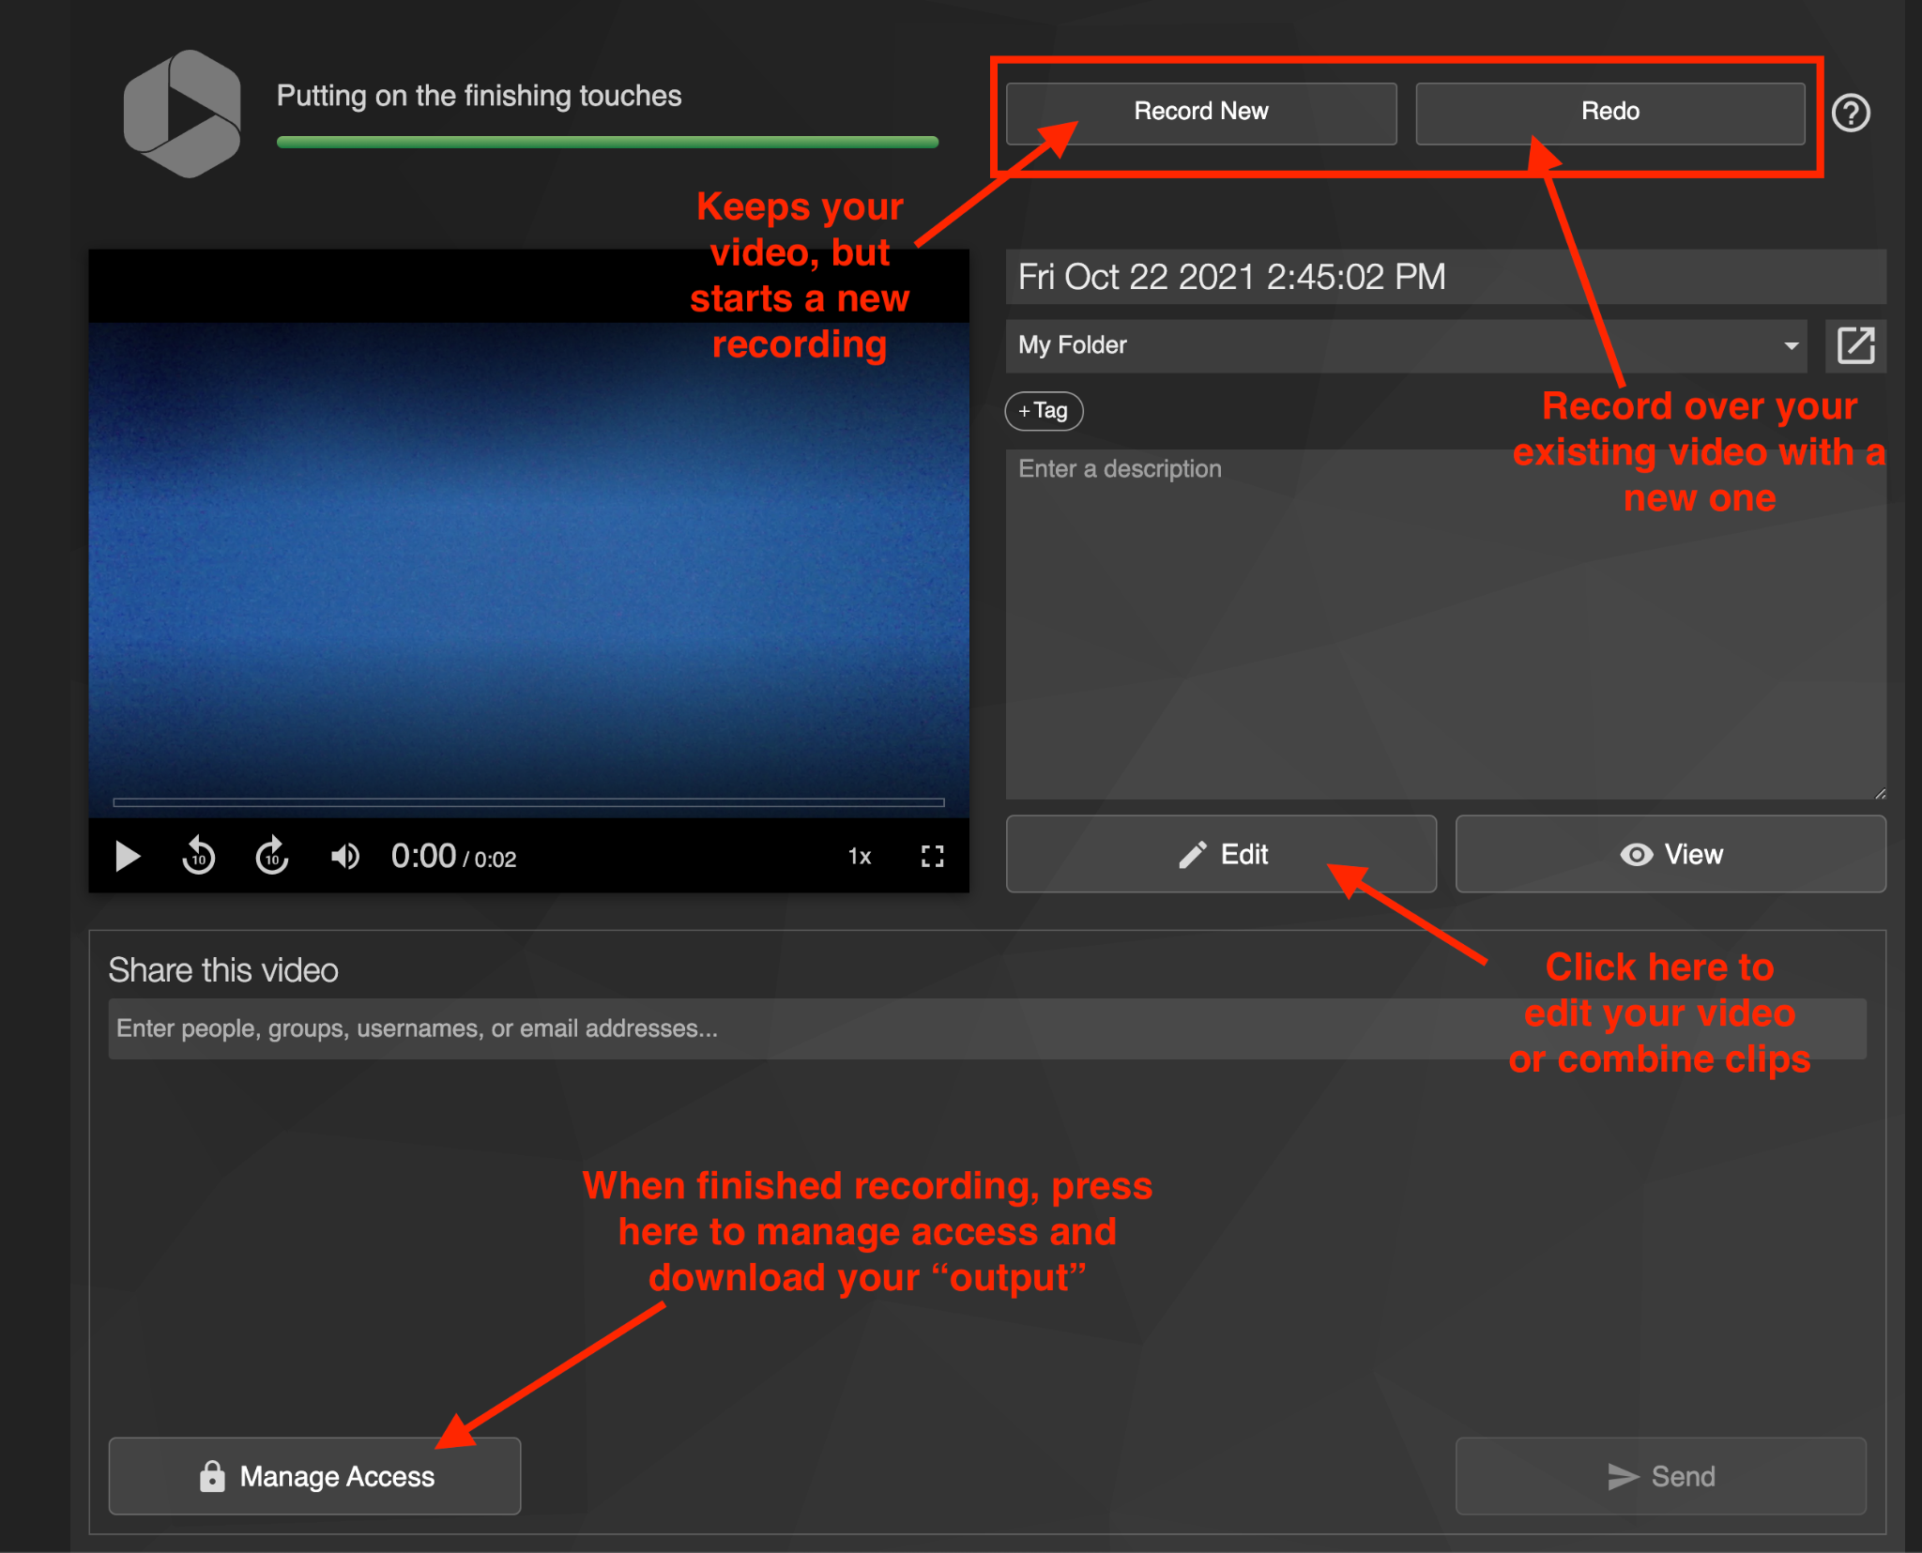

- From the review screen, there are some choices to make:
  - Record New:
    - Keep your original recording, but jump into a new recording with one click.
  - Redo:
    - Not happy with your recording? Record over your existing recording by clicking here.
  - Edit:
    - Is your recording pretty good, but you want to remove a short piece where you stumbled? Edit out short sections of your video by clicking here on the review screen.
  - Manage Access: (use this to download your video when finished)
    - Happy with your video and don’t need to edit it? Congratulations! Click “Manage Access” to open the window for your video settings. From here, you’ll be able to download your video
    - Go to “Outputs” from the menu on the left hand side of the window
    - Choose the type of view you’d like your presentation to have. Typically, people choose “Side by Side” or “Picture in Picture”.
    - When done processing your selection, you’re ready to download your video.
    - Click on “Download Podcast” to download a .mp4 file of your recording for uploading to Youtube!
    - 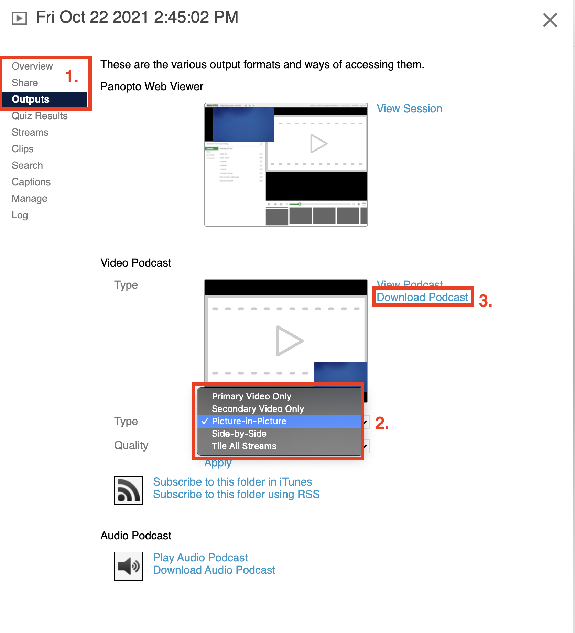
- For more information on using Panopto Capture, please click HERE.

Uploading existing media into Panopto

- Already record your video in Zoom, but need to edit the video in Panopto? Upload it by using the “upload media” function in Panopto!
- To get started, first locate the file(s) you know you’ll want to upload to Panopto, either to submit as is or to use them as clips in other existing recordings.
  - If you plan to upload media to use as clips in other existing recordings, be sure to cut them down exactly as you want them before you upload. Panopto’s editing software can perform cuts, but not to added clips.
- After deciding what files you want to add to your Panopto, go to your https://longwood.hosted.panopto.com/ page.
- Then, go to “My Folder” along the left-hand page. This will ensure that your videos can be used regardless of what course you’re in, making it easier to use these files later on.
  - Important Note: You will only have a “My Folder” if you’ve been made a Creator in Panopto. Most likely, students will only have access to course assignment folders. In such cases, substitute all incidents of “My Folder” with “Course Folder” from here on out in the guide.
- Click on the dark blue “Create” to open a dropdown menu.
- Then, click on “Upload Media”.
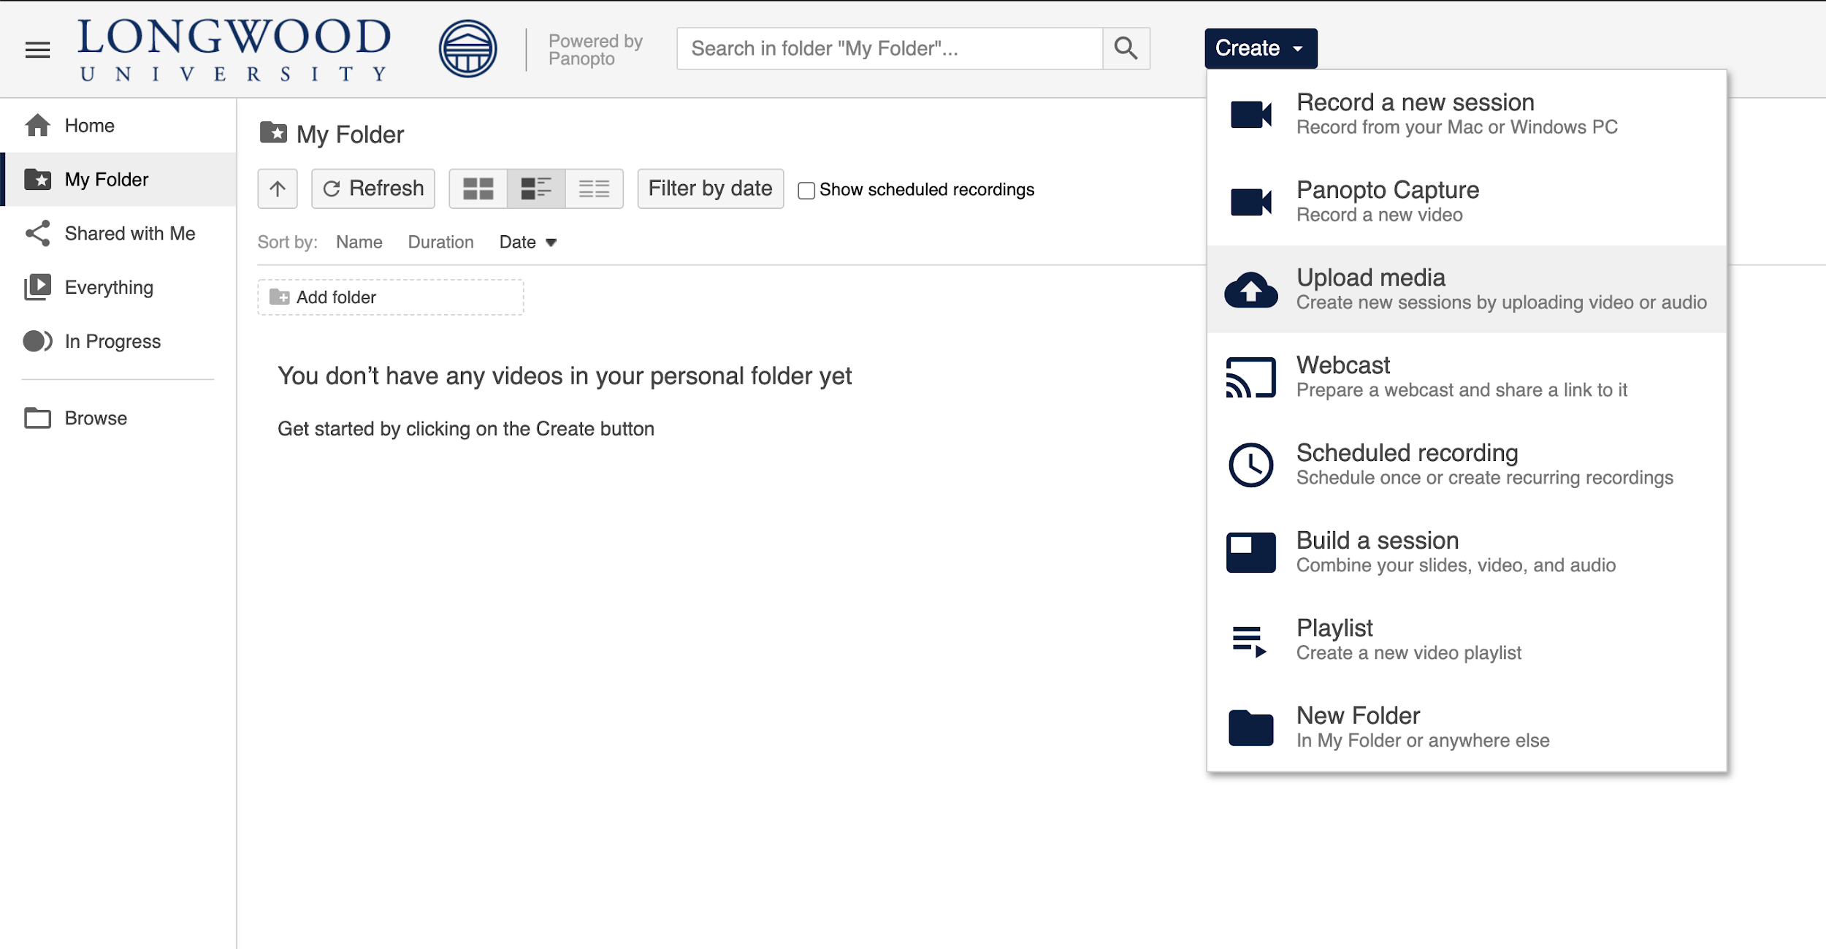

3
4
5
- A new window will pop up in your browser, prompting you to add the desired existing media. At the top of the window, you can change where you want to send these files in your Panopto if you choose to. Click on the “Choose video or audio files” in the center of that window. Alternatively, you should be able to “drag and drop” the desired files.
- Locate the files you want to upload. Then, click on “Open” in the bottom right.
- Wait for the files to upload and process. Once they are done processing, they will show up in My Folder (or other location) just like any other Panopto recording and you’ll be able to edit their details, edit the video, share it, etc.

Adding clips to a video in Panopto

- Use this guide if you’ve recorded multiple videos that you’d like to merge together into one!
- First, you’ll want to find the video in Panopto that you want to add a clip to.
  - You’ll also want to have already uploaded the videos you want to add as clips to your Panopto. When you upload media that you know you want to use as a clip, make sure they are already trimmed to where you want them to start and stop, as Panopto doesn’t allow cuts to be added to clips. See the above section for guidance.
- Once you locate that video, hover over it to reveal more option buttons underneath its name. Click on “Edit”.
- You’ll be brought to the Panopto editor. You can see a video preview in the top right section, various tabs for content and editing capabilities on the left-hand side, and your timeline along the bottom. If you had two video sources (for example, your webcam and your recorded powerpoint on your screen) you’ll see a video preview in the top left and the top right.
- Click on the timeline where you want to add a clip. You’ll know where it will be added by the red line indicating where you are in the video.
- Just above the timeline and below the video preview are some editing options. Just to the right of the scissors icon is a plus sign. Click on that to show more options of content you can add.
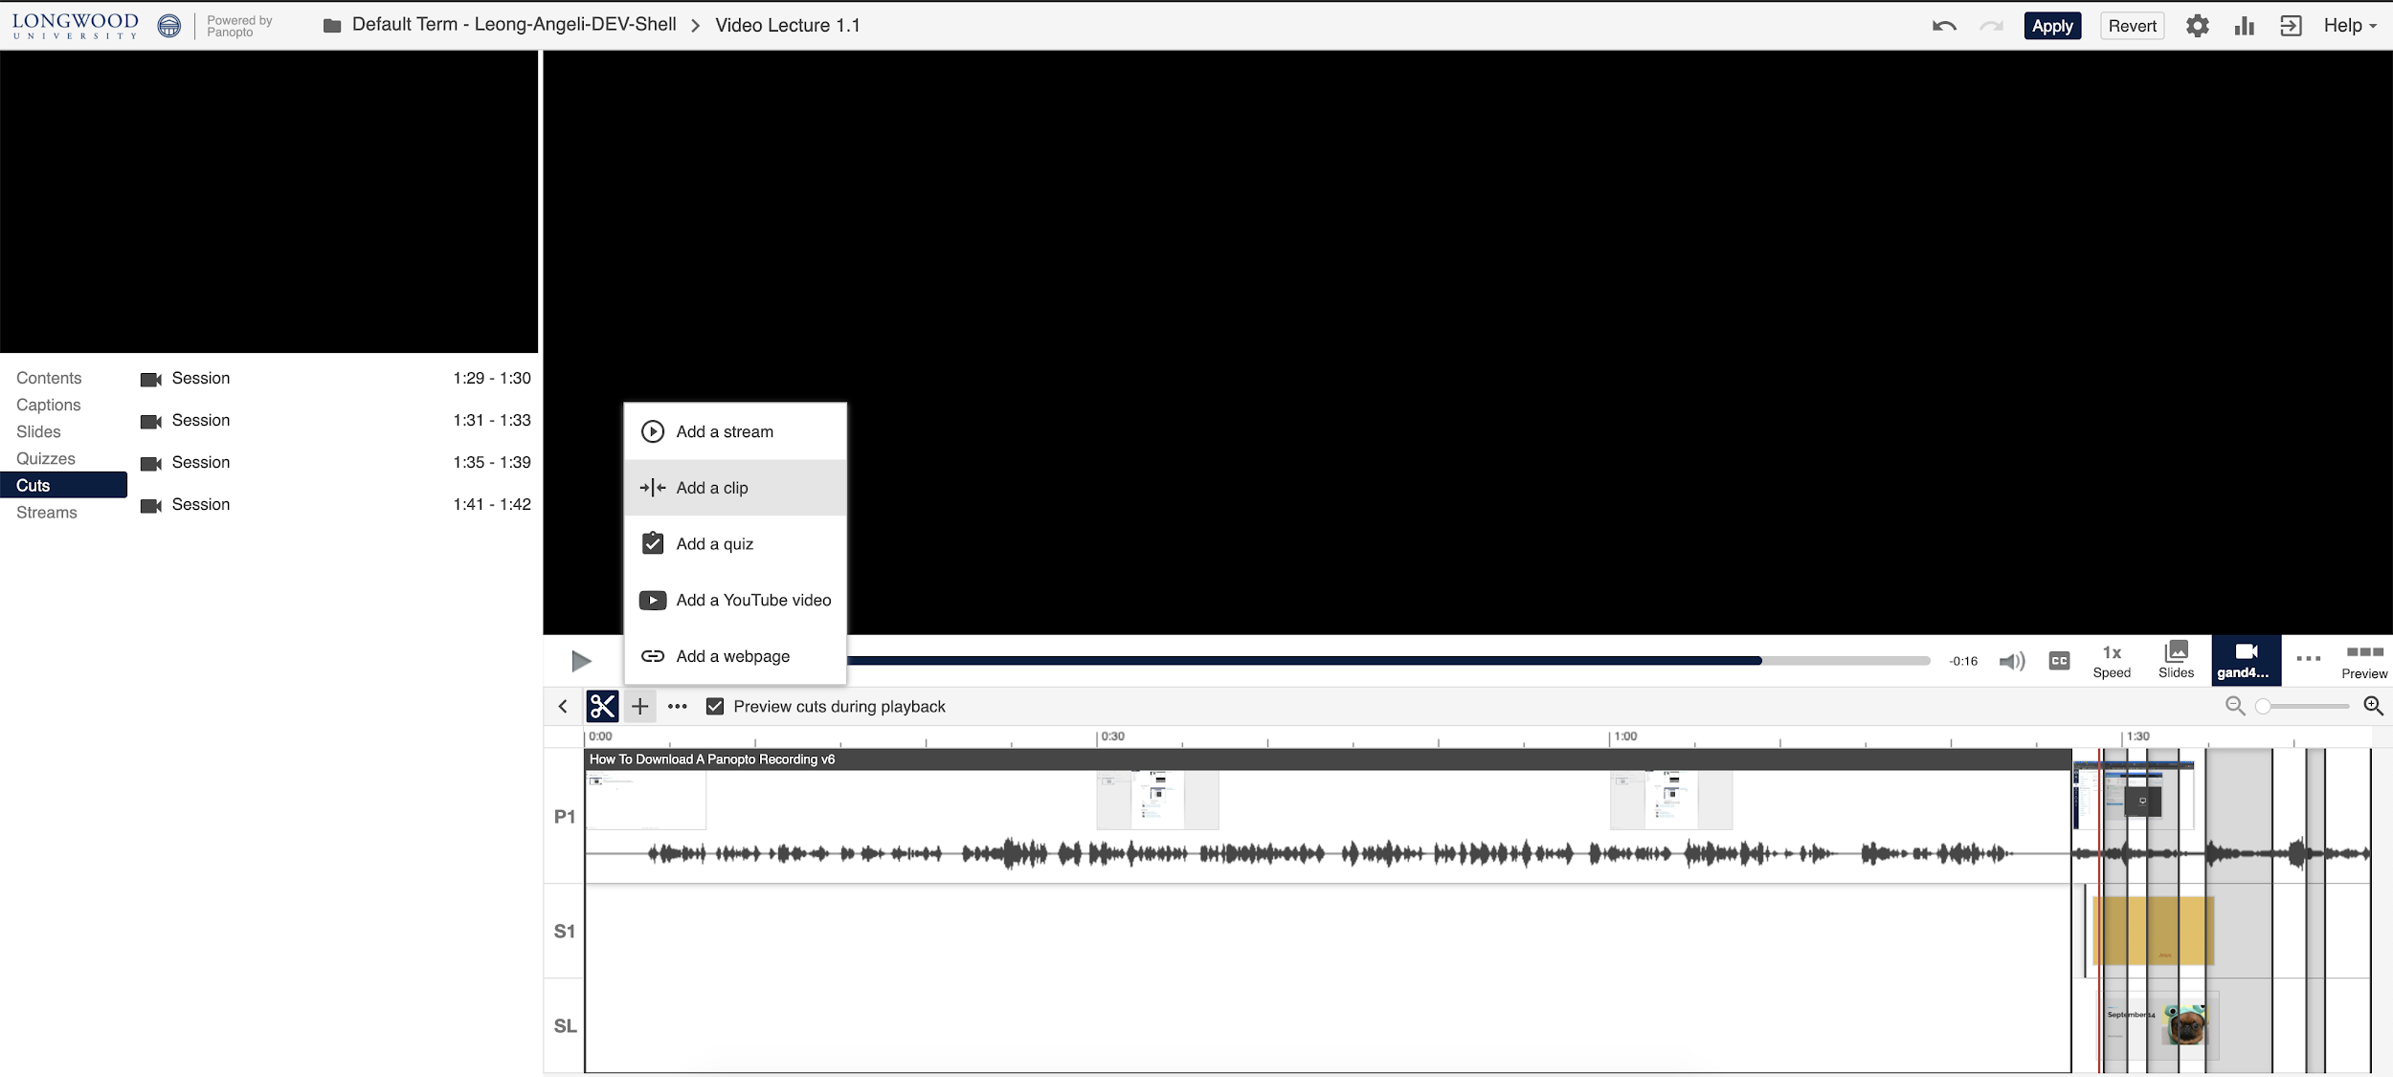
- Click on “Add a clip”.
- Once you click “Add a clip”, a new window will appear prompting you to browse for the video you want to add.
- Click on the dropdown at the top to show folders and courses available to you. Or, if you know the specific name of the file, you can use the search bar just to the right of the dropdown menu.
- Once you select a video, the previous window will close and you’ll be taken back to the Panopto editor. Your clip will show up in full duration on the timeline where you had previously put your red cursor. It will appear as a dark grey box with the title of the recording along the top of the box.

Making cuts to a video using Panopto

- If you’re following these instructions right after the above section on adding clips, then you’re already in the right place. Skip to step 4.
- To get started, first find the video you want to edit. Hover over the video to reveal more option buttons, and click on “Edit”.
- You’ll be brought to the Panopto editor. You can see a video preview in the top right section, various tabs for content and editing capabilities on the left-hand side, and your timeline along the bottom. If you had two video sources, you’ll see a video preview in the top left and the top right.
- To begin making cuts, simply click and drag over a portion of the timeline. You can do more fine adjustments later. You’ll know if it cut the video because a section of the timeline will be greyed out, and when you play the video to preview it, the red time indicator will just skip that greyed out area.
- If you need the cut to start/end at a more specific point in your video, click on “Cuts” along the left-hand navigation menu. This will show you an overview of all the cuts you’ve made to your video, as well as the timestamps which they affect. You can edit and delete them from here.
- To edit or delete a cut, hover over the name of the cut and three dots will appear next to the timestamps. Click on that to reveal “Edit” or “Delete”.
- If you choose to Edit your cut, you will be able to type in a custom start and end time for it. It is formatted as HH:MM:SS.MS to allow you to get right down to the millisecond.
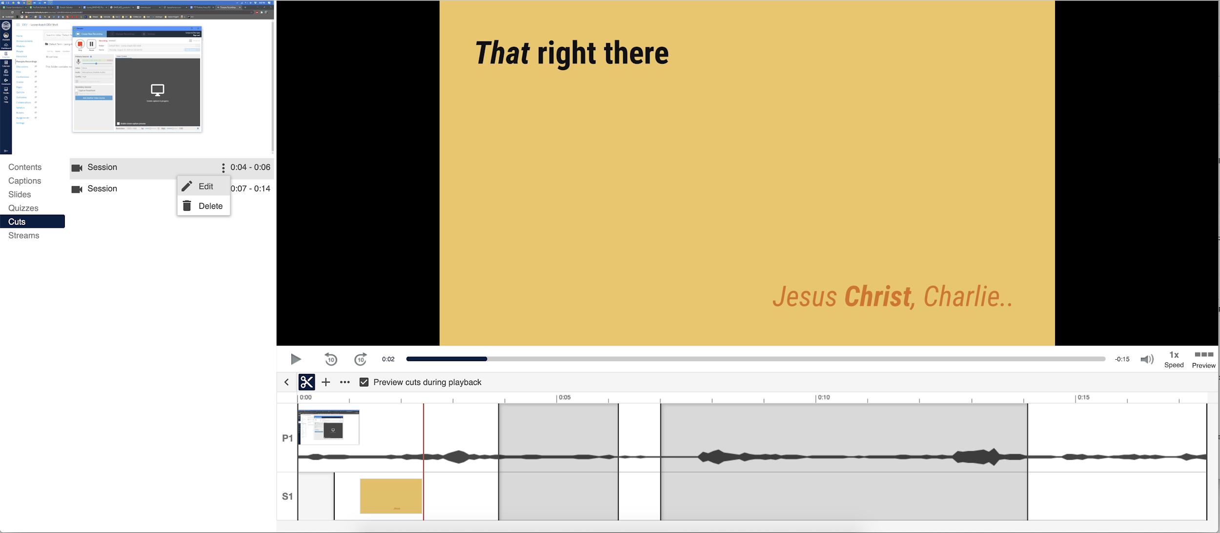

Exporting your finished video to .mp4 “podcast”

- First, locate the recording you want to export to a .mp4 file. Hover over it to show more option buttons, and click on “Share”.
- A new window will appear in your browser showing the settings and options for that recording. Along the left-hand side of that window are some subpages. Click on “Outputs”.
- Go down to “Video Podcast”. You will see a preview of your recording and some options for your download just below that.
- By default, a recording’s download settings will be as a side-by-side at 720p, 30fps. If you’re happy with these settings, simply click on “Download Podcast” to the right of the video preview.
  - “Type” refers to how you want the video sources to be arranged in your download, such as side-by-side, over top of one another, or just one source at a time.
  - “Quality” refers to how the video will appear to your audience. Generally, the higher the numbers the better, but for a class lecture or presentation assignment, 720p at 30 frames per second is sufficient.
- If you want to change the Type or Quality of the video, be sure to click on “Apply” below it to save those changes. The “Apply” button will only show if you’ve made changes.
  - Keep in mind that setting it to download at a quality that is higher than what the recording was created in will not boost the quality. For example, if you recorded at 30 frames per second, attempting to download it at 60 frames per second will still only download it at 30 fps.
- Your video should begin downloading to your computer.
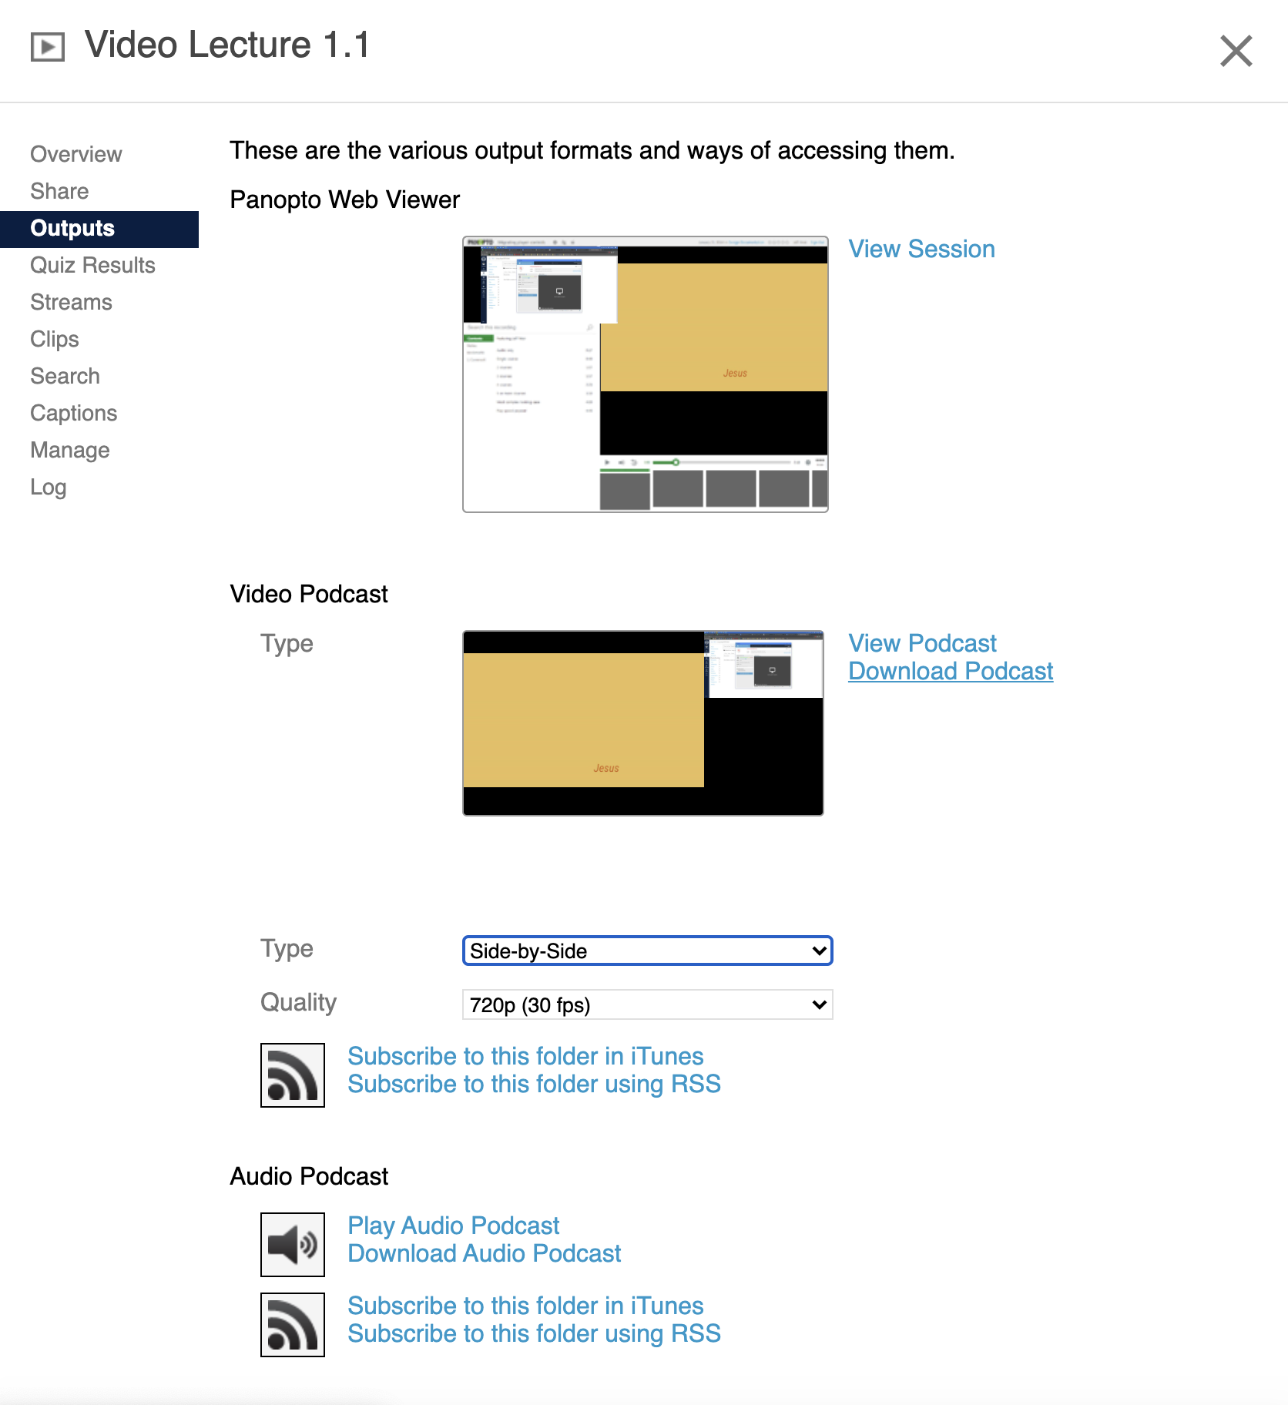

Creating an Unlisted Youtube Video
Video of how to make an unlisted Youtube Video

- First, you’ll need a recording that is saved to your computer. There are several ways to record a video, so just use whichever software you prefer. Save the video to a place you’ll be able to find later. Two common locations are “Desktop” or “Documents”.

- Then, head to the YouTube homepage.
- In the top right corner, there’s a small camera icon with a plus sign to the left of the apps, notifications, and channel icon. When you hover over it, it will say “Create”. Click on the camera icon.
- Click on “Upload Video”.
- If you’ve uploaded videos before, YouTube won’t prompt you to create/customize your channel. Instead, you will be taken directly to step 6.
  - If this is your first time uploading videos, you’ll see a small window encouraging you to customize your channel and get started on your creative journey. To continue uploading your video, you have to click on “Get Started”. You cannot skip this process.
  - Follow the prompts to customize your channel as you see fit. Most, if not all options are able to be changed later on.
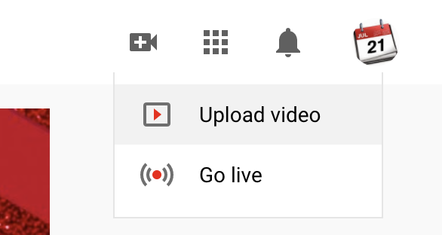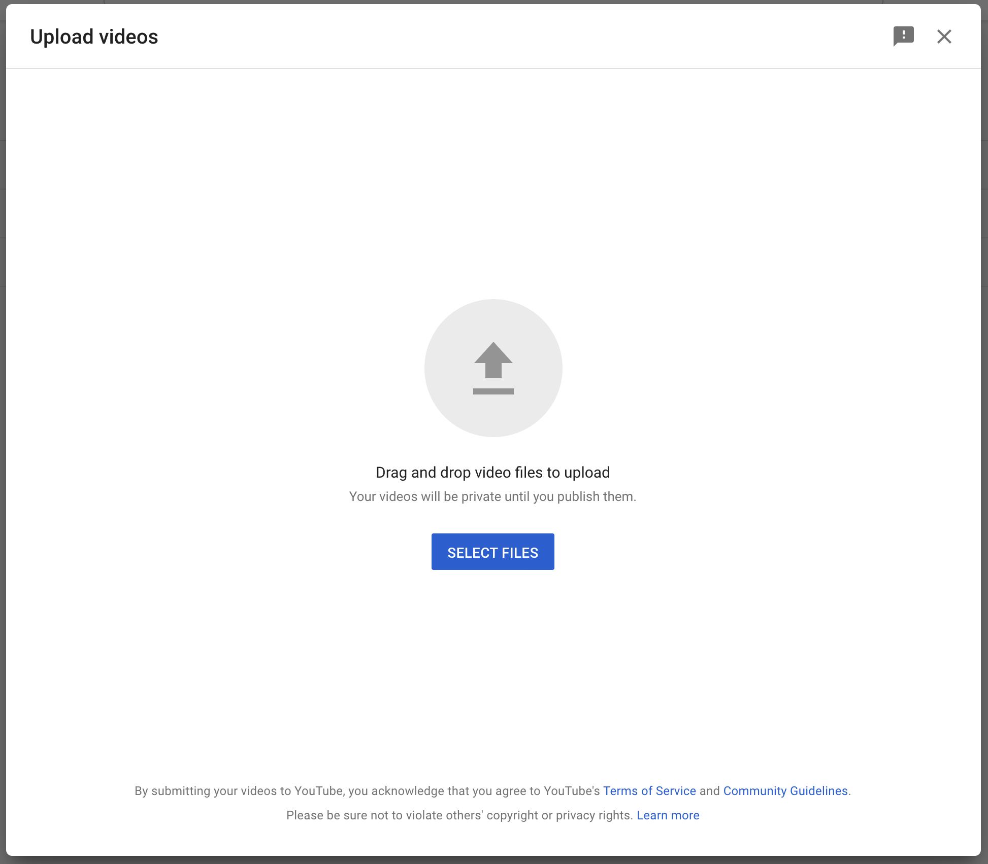
- An “Upload Videos” window should now be in the center of your browser, with the rest of your Channel Videos page greyed out in the background, if you have any.
- You can either drag and drop the video into the smaller window, or you can click on the arrow or “Select files” to proceed.
  - If you clicked on the arrow or “Select files”, your finder/file explorer will open up and you will be prompted to find your video/recording.
- Once your video begins uploading, your window will change to show you “Details” options, such as adding a title and description to your video. This would help viewers be able to determine if they’re watching the correct video. If you scroll down a bit, you also have the options to add a thumbnail or add the video to a playlist.
- The “Video Elements” tab at the top of the smaller window contains options to add an end screen, which shows up at the end to promote your other videos, and/or cards, which show up when you want to during the video.
- The “Visibility” tab at the top of the smaller window (third dot along the progress path) has the options to change who can view your video once it’s uploaded and processed, or you can schedule it to be public after a certain date.
- Here is where you can put a check mark by “Unlisted”.
  - *This step is essential for correct viewing of your presentation in the Forager 1 site.*
- Then, click “Save” in the bottom right of the smaller window.
- Once you click “Save”, another window will appear giving you options to share the video, such as by a paste-able URL or directly to certain social media.
